**Power Learn Project**

**Setting up Development Environment assignment**

**Siyabonga T. Pika**

As seen in Figure 1 below, the operating system is already installed on the computer that I am using. I am therefore concerned about installing a different version because it might not work with some of the computer's installed apps. Windows 10 Enterprise version 22H2 is the one that is presently installed.

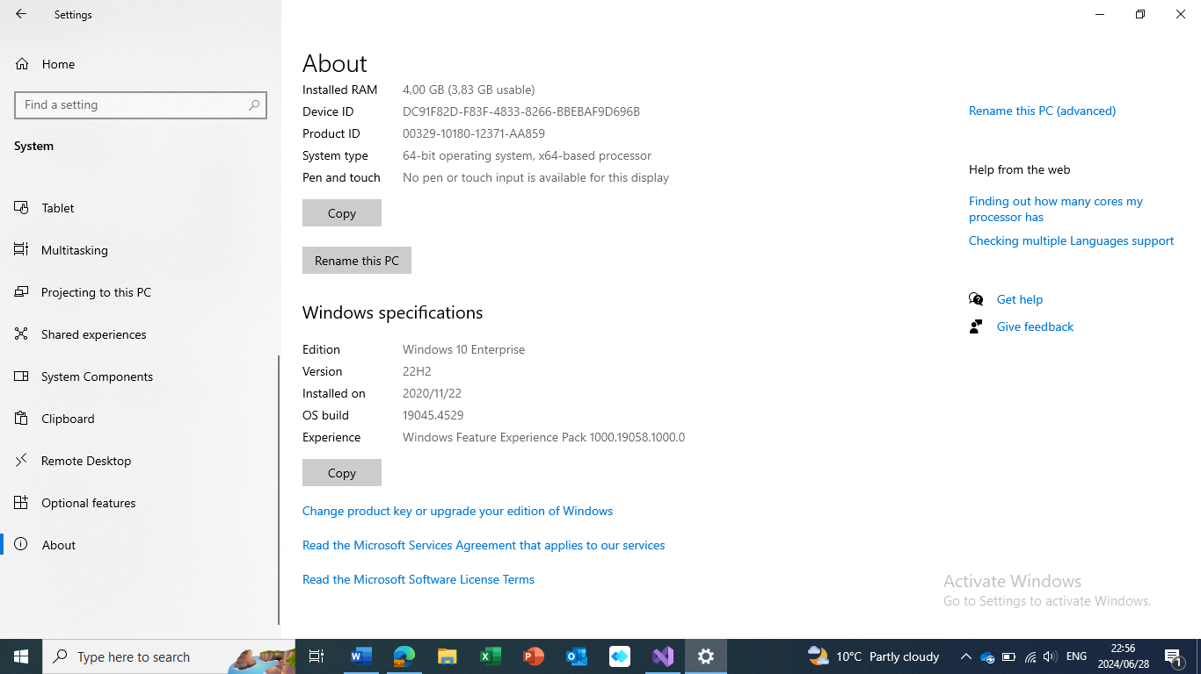

Figure 1: Operating System specifications

Visual Studio 2022 is the Integrated Development Environment installed in the computer as Figure 2 below shows.

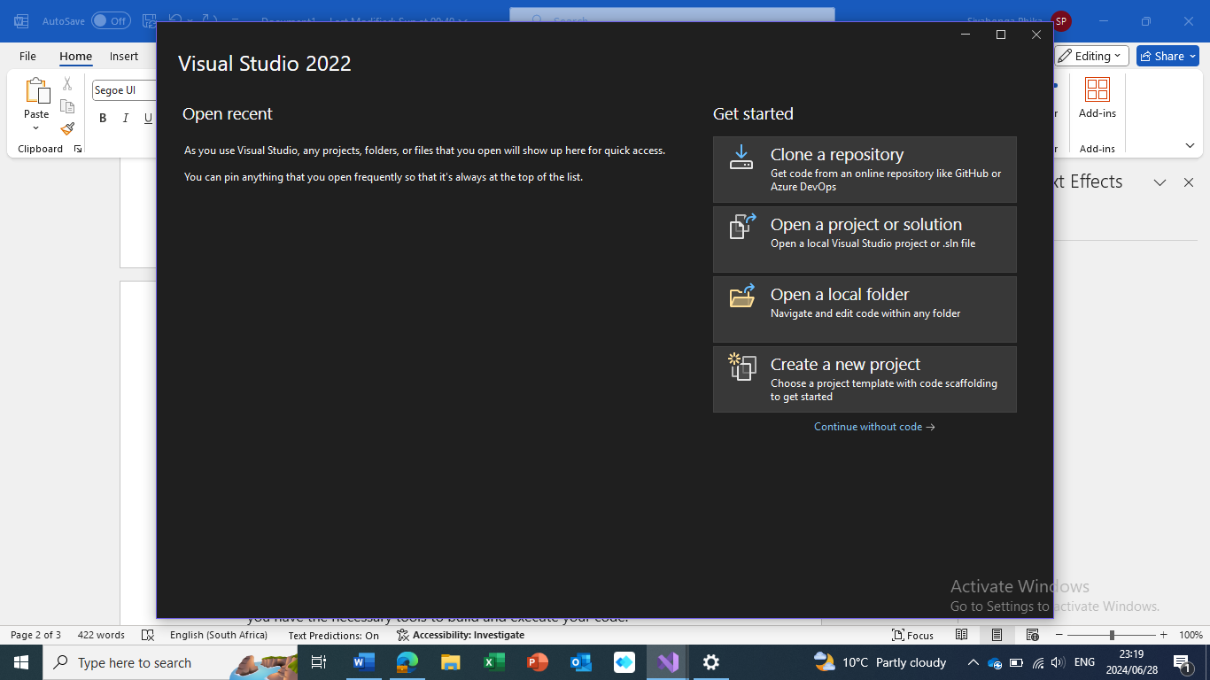

Figure 2: Integrated Development Environment

My Github account has been created as depicted in Figure 3 below. It can be accessed through this link [sphika (Siyabonga T Pika) (github.com)](https://github.com/sphika)

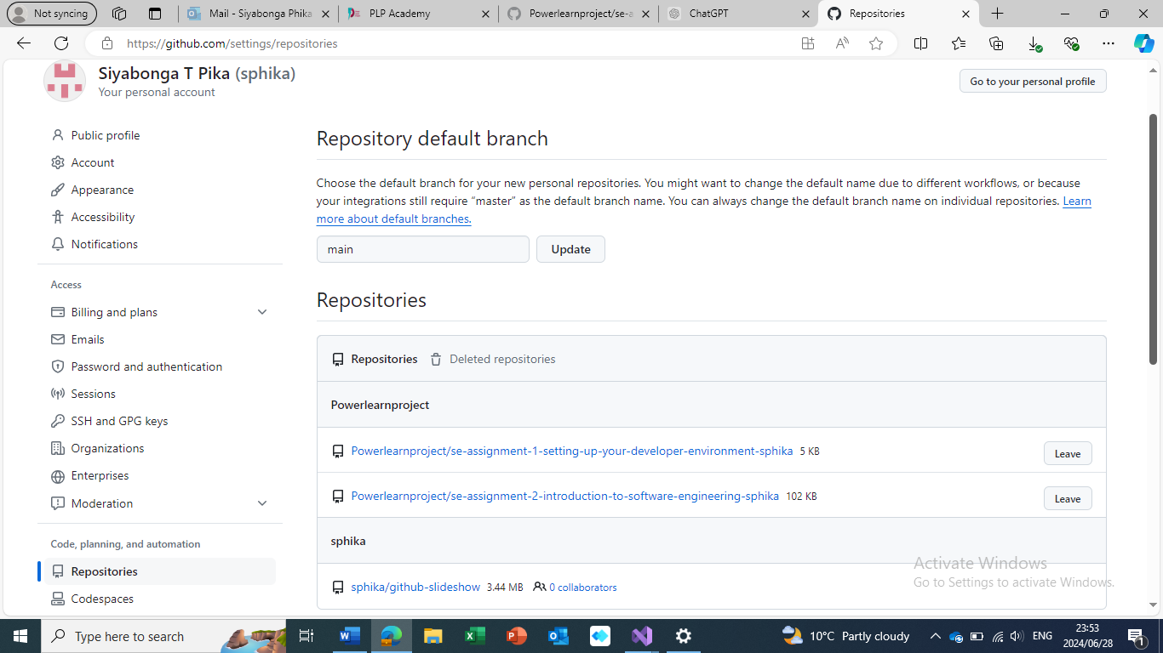

Figure 3: Github account

Figure 4 below depicts that Python programming language is installed as part of the Visual Studio 2022 version.

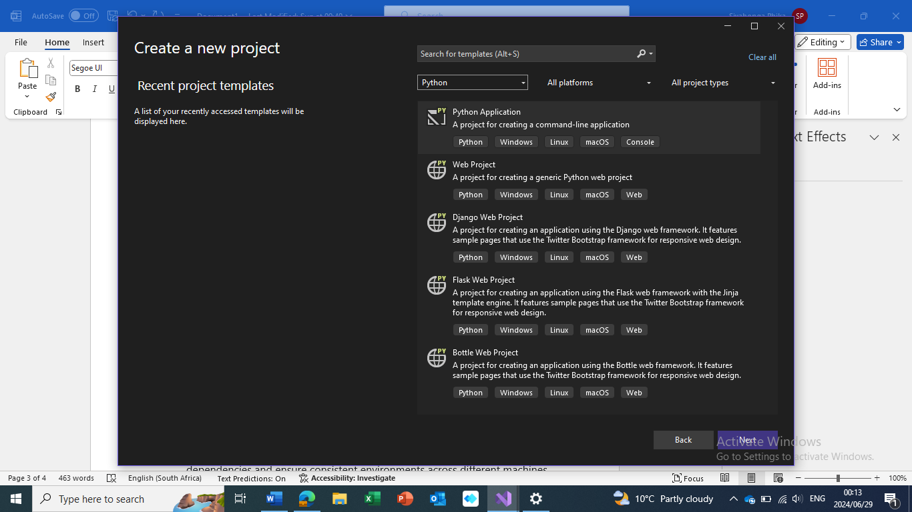

Figure 4: Python programming language

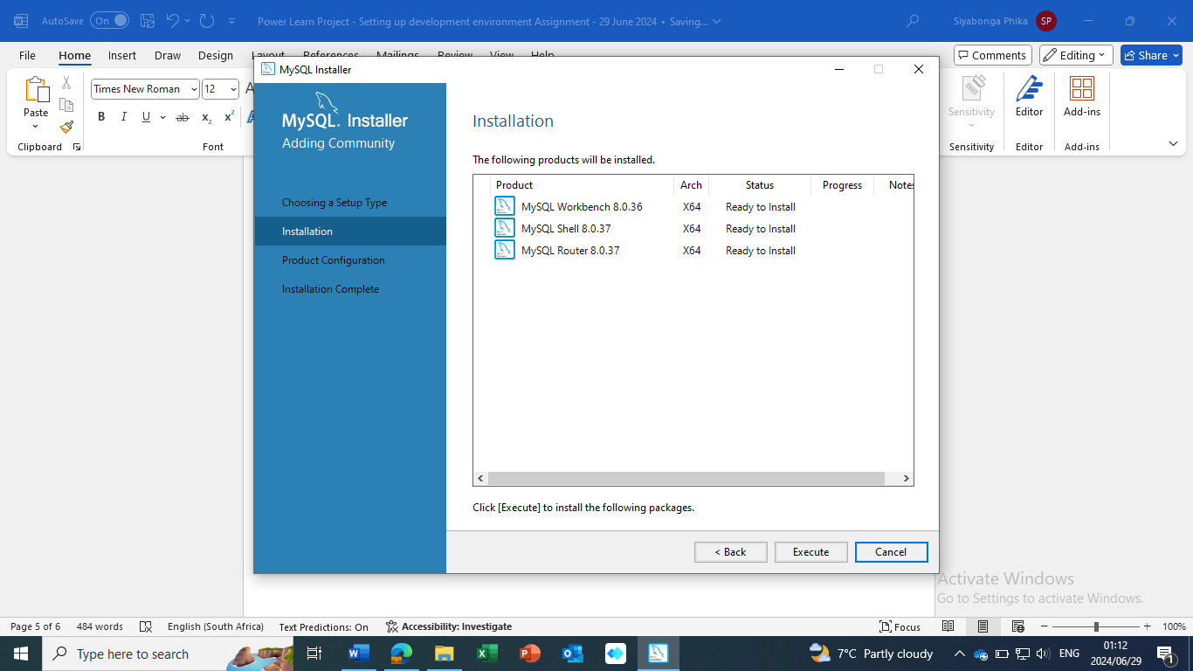Figure 5 below shows the installation of MySQL.

Figure 5: MySQL installation

Figure 6 below indicates that MySQL Workbench was successfully installed, but MySQL server could not be detected, suggesting that it may not have been installed properly or it was not running at the time. Currently, I do not have expertise in MySQL and as a result, I cannot not resolve this challenge. However, I believe that as I continue to engage with the learning material and lessons, I will resolve the current limitation.

